**CSE523** Machine Learning

Project: Shipment Price Prediction

Weekly Project Report: March 30, 2023

Team: **Revolution**

|  |  |
| --- | --- |
| Team Members | Enrolment-ID |
| Deep Patel | AU2040250 |
| Roshni Navdiya | AU2040114 |
| Aditya Padhariya | AU2040151 |
| Keval Parmar | AU1940133 |



* **Task Performed this week:**

1. Calculated adjusted R2 value of selected algorithms and decided to go with the Gradient boost algorithm.
2. Training data and testing data as per the gradient boost and removing unnecessary data.

* **Outcomes of the tasks performed:**

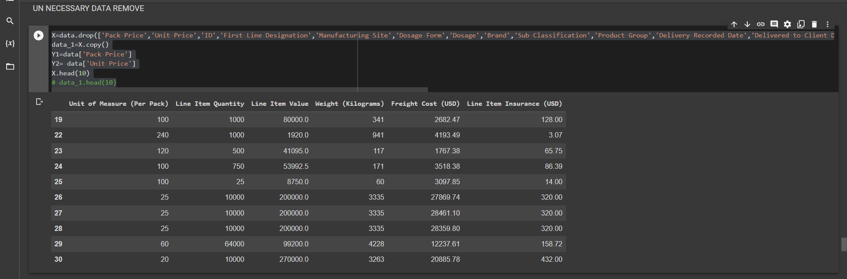

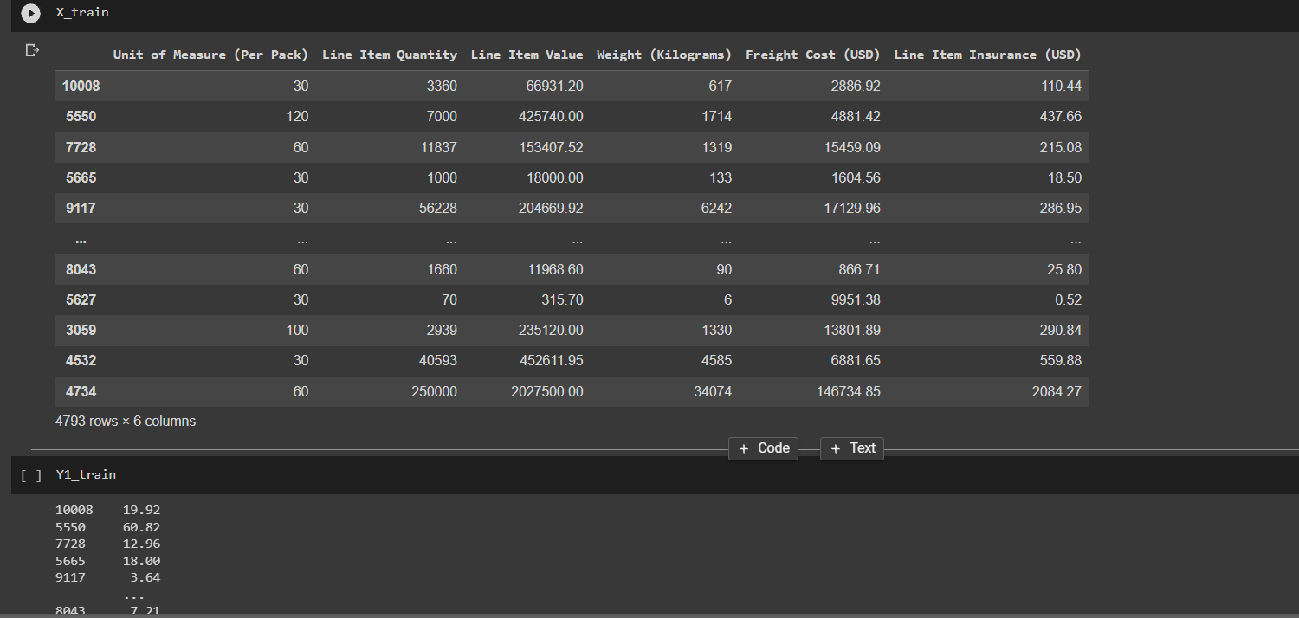

* **Tasks to be performed in the upcoming week:**

1. Started the work on planning and building the front end.
2. Still some modifications to be made on training and test data.